This article is distributed by NASA Night Sky Network
The Night Sky Network program supports astronomy clubs across the USA dedicated to astronomy outreach. Visit nightsky.jpl.nasa.org to find local clubs, events, and more!

Chill Out: Spot an Ice Giant in August
By David Prosper

Is the summer heat getting to you? Cool off overnight while spotting one of the solar system’s ice giants: Neptune! It’s the perfect way to commemorate the 30th anniversary of Voyager 2’s flyby.

Neptune is too dim to see with your unaided eye so you’ll need a telescope to find it. Neptune is at opposition in September, but its brightness and apparent size won’t change dramatically as it’s so distant; the planet is usually just under 8th magnitude and 4.5 billion kilometers away. You can see Neptune with binoculars but a telescope is recommended if you want to discern its disc; the distant world reveals a very small but discernible disc at high magnification. Neptune currently appears in Aquarius, a constellation lacking in bright stars, which adds difficulty to pinpointing its exact location. Fortunately, the Moon travels past Neptune the night of August 16th, passing less than six degrees apart (or about 12 Moon widths) at their closest. If the Moon’s glare overwhelms Neptune’s dim light, you can still use the its location that evening to mark the general area to search on a darker night. Another Neptune-spotting tip: Draw an imaginary line from bright southern star Fomalhaut up to the Great Square of Pegasus, then mark a point roughly in the middle and search there, in the eastern edge of Aquarius. If you spot a blue-ish star, swap your telescope’s eyepiece to zoom in as much as possible. Is the suspect blue “star” now a tiny disc, while the surrounding stars remain points of white light? You’ve found Neptune!

Neptune and Uranus are ice giant planets. These worlds are larger than terrestrial worlds like Earth but smaller than gas giants like Jupiter. Neptune’s atmosphere contains hydrogen and helium like a gas giant, but also methane, which gives it a striking blue color. The “ice” in “ice giant” refers to the mix of ammonia, methane, and water that makes up most of Neptune’s mass, located in the planet’s large, dense, hot mantle. This mantle surrounds an Earth-size rocky core. Neptune possesses a faint ring system and 13 confirmed moons. NASA’s Voyager 2 mission made a very close flyby on August 25, 1989. It revealed a dynamic, stormy world streaked by the fastest winds in the solar system, their ferocity fueled by the planet’s surprisingly strong internal heating. Triton, Neptune’s largest moon, was discovered to be geologically active, with cryovolcanoes erupting nitrogen gas and dust dotting its surface, and a mottled “cantaloupe” terrain made up of hard water ice. Triton is similar to Pluto in size and composition, and orbits Neptune in the opposite direction of the planet’s rotation, unlike every other large moon in the solar system. These clues lead scientists to conclude that this unusual moon is likely a captured Kuiper Belt object.

Discover more about Voyager 2, along with all of NASA’s past, present, and future missions, at nasa.gov
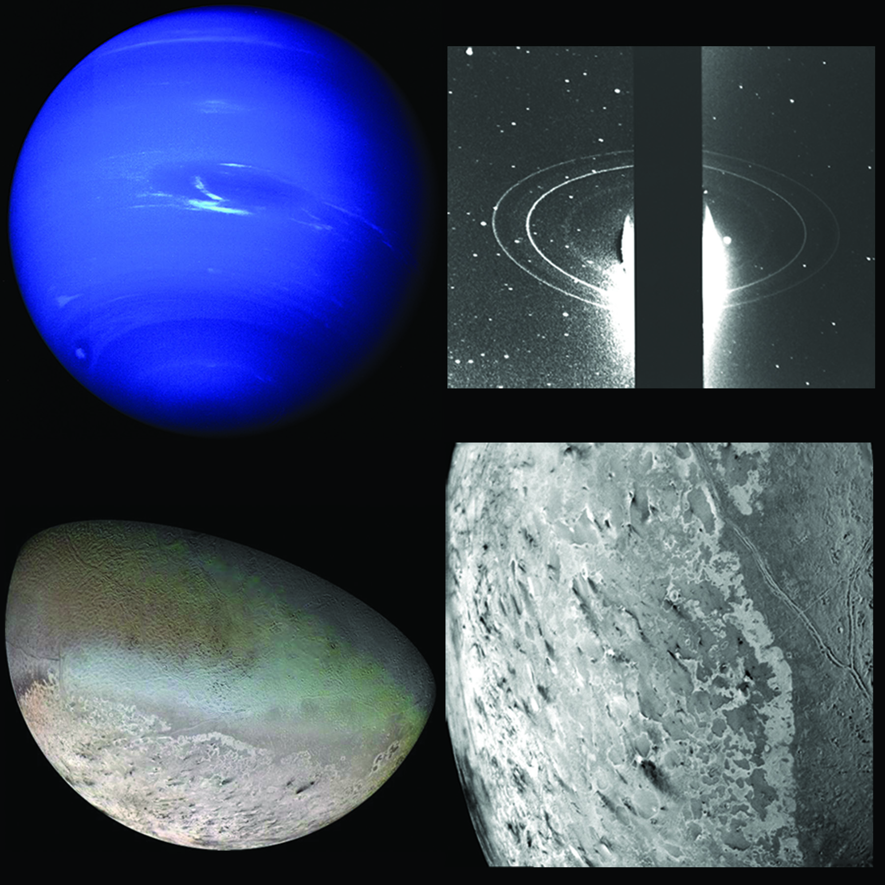
Clockwise from top left: Neptune and the Great Dark Spot traced by white clouds; Neptune’s rings; Triton and its famed icy cantaloupe surface; close of up Triton’s surface, with dark streaks indicating possible cyrovolcano activity. Find more images and science from Voyager 2’s flyby at bit.ly/NeptuneVoyager2 Image Credit: NASA/JPL

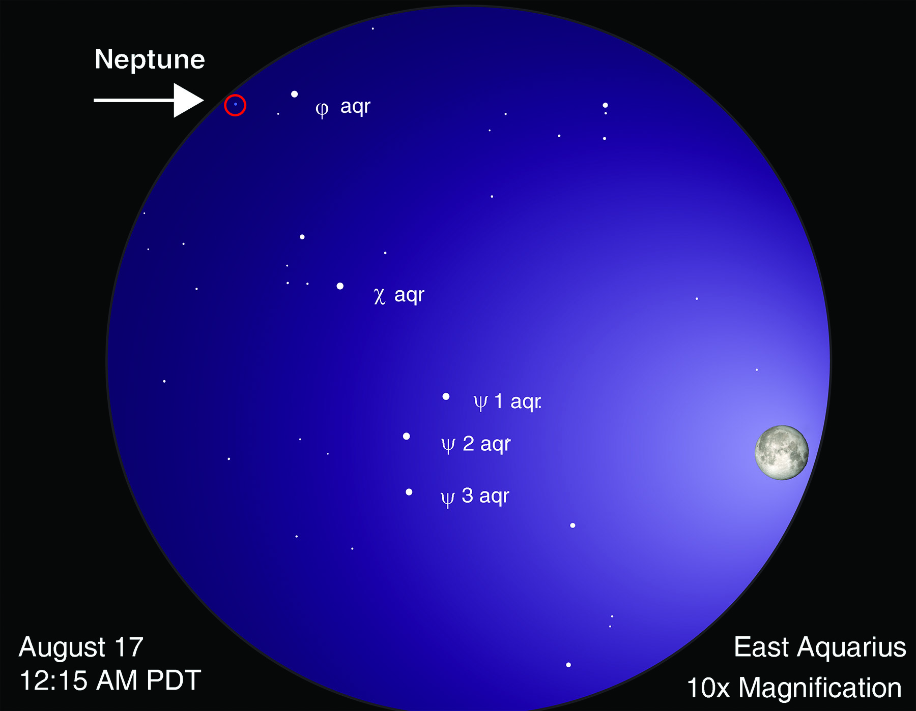
Finder chart for Neptune. This is a simulated view through 10x50 binoculars (10x magnification). Please note that the sizes of stars in this chart indicate their brightness, not their actual size. Moon image courtesy NASA Scientific Visualization Studio; chart created with assistance from Stellarium.

