19 October 2019 Aerospace Evening
at University of Nebraska in Omaha

On a blustery Saturday evening, volunteers set the stage for an engaging science outreach event at the University of Nebraska in Omaha, inside the Durham Science Building. This article highlights events at the Aerospace Evening educational outreach event during 19 October. The events are possible by sponsoring schools, teachers and organizations educating the public on science, technology, engineering and math topics. Also, the author and the many volunteering teachers send a big thank you to the Aerospace Corporation, Astronomy Magazine and the Night Sky Network. Aerospace Corp provided awesome backpacks, rocket pens and ear buds for the school children! Astronomy Magazine issued slick astronomy booklets on what to observe in the night sky! The Night Sky Network provided posters and Sun and planet displays! Over 250 students and families attended the free, fun, and educational evening of science.

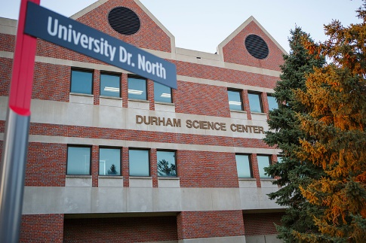
Photo 1: University of Nebraska, Omaha Durham Science Center
Photo by: unomaha.edu

Aerospace Evening is a collection of twelve hands-on activities introducing the public to simple experiments and scientific principles. Multiple activities engaged elementary school children, such as constructing and launching their own straw rockets. Construction paper, tape, clay and soda straws compose the rockets. The children use air launchers, as seen in Photos 2, 3 and 4, aiming their rocket towards target pictures of the Moon, Mars and Pluto. They launch multiple times, analyzing how to land their rocket closer to the target – by adjusting the thrust, reducing mass or trimming fin sizes.

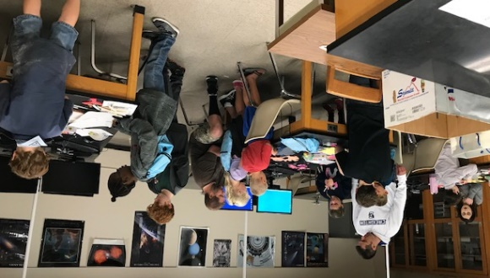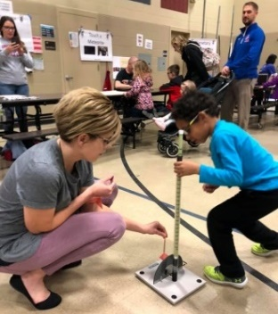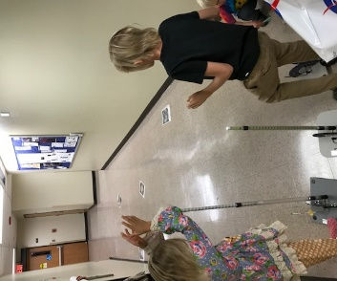
Photos 2, 3 and 4: Straw Rocket Design and Launching
Photos by: Wendy Kaupa
More activities involve participants constructing balsa wood kit gliders and then land the gliders on a runway. Here, children of all ages practice tossing the gliders and make adjustments. Land too far left of the runway? Need to move the wings in the opposite direction. Toss the glider too far? In Photos 5 and 6, you will have chase down the winged demonstrator!

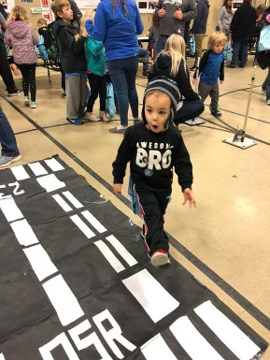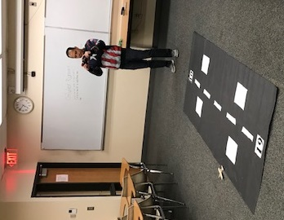
Figure 5 and 6: Coming in for a landing!
Photo by: Wendy Kaupa

All enjoyed a table of “freebies” designed to grab everyone’s full attention. Ink pens in the shape of rocket ships, baseball style cards with one side depicting a planet image and the other side offering facts, pictures of galaxies and thanks to a generous donation from the Aerospace Corporation, a drawstring backpack to carry their treasures! Plus pamphlet full of Astronomy pictures, thanks to Astronomy Magazine!

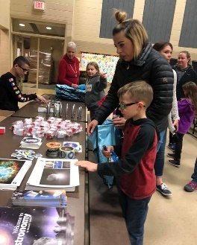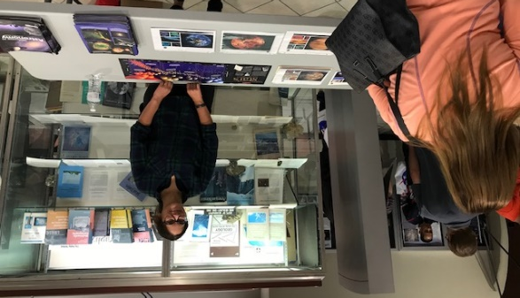
Photos 7 and 8: Aerospace Corporation and Astronomy Magazine handouts
Photo by: Wendy Kaupa

More activities awaited the apprentices, including static electricity experiments with the van de Graaf generator. In Photo 9, school children learned how shuffling socked feet on carpeting during a dry day leads to shocking static electricity. The apprentices zipped over to the next tables where they designed their own circuits. Circuits, in Photo 10, where the students illuminated lights, created tones, or even launched propellers into the air.

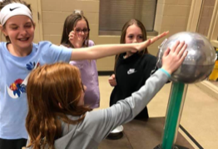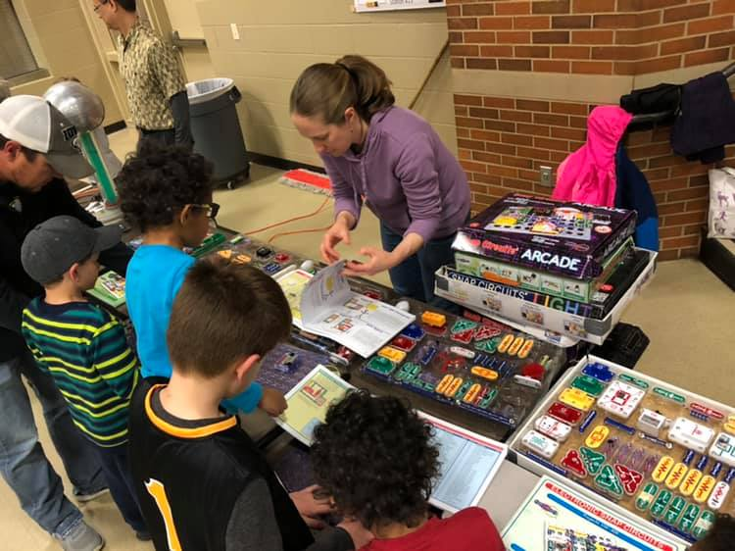
Photo 9: Shocking Methods of Static Electricity Photo 10: Create Your Own Circuit
Photos by: Wendy Kaupa

Astronomers from the Omaha Astronomical Society were on hand answering questions and explaining how telescope works. Viewing the night sky yielded the king of the planets, Jupiter, low in the southwest sky. Scouts asked the astronomers many questions ranging from what is a black hole to how do stars die? They also sketched Ursa Major in fulfillment of the astronomy badge requirements.

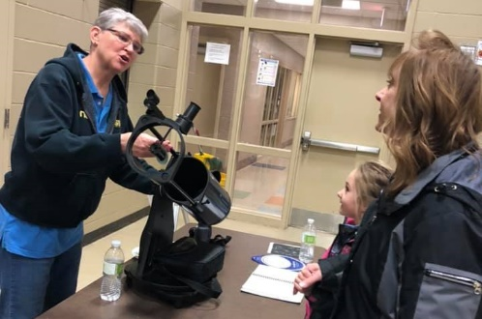
Photo 11: Awesome Astronomers Explaining Telescopes
Photo by: Wendy Kaupa

Need more rocket experiences? Aerospace Evening has more rocket insight with Alka Seltzer tablets and old, 35mm film canisters. The seltzer rockets proved to be another hit among the kids as they watched wide-eyed when the film canisters shot straight into the air nearing the ceiling. No matter how many times a canister was fired skyward, exclaims of, “Wow! That is so high!” could be heard.

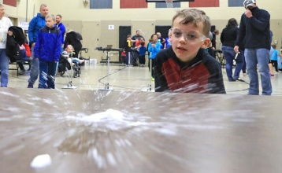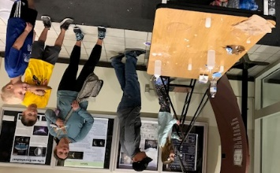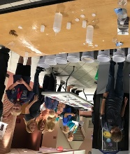
Figure 12, 13 and 14: Seltzer Rockets Launch!
Left Photo by: Joe Shearer, Nonpareil Newspaper
Middle and Right Photo by: Doug Kaupa

Even wonder how the Space Shuttle returned from space slicing through Earth’s atmosphere and not burn up like meteors? UNO Physics department has an authentic shuttle tile which volunteers apply a blow torch for several minutes, allowing students to see how the black tiles reject nearly 99% of the heat applied. Using an infrared temperature gauge, students witness the temperature climb from room temperature upwards of 500°F. After the blow torch is removed, everyone touches the underneath of the tile and discovers the temperature there is only warm to the touch!

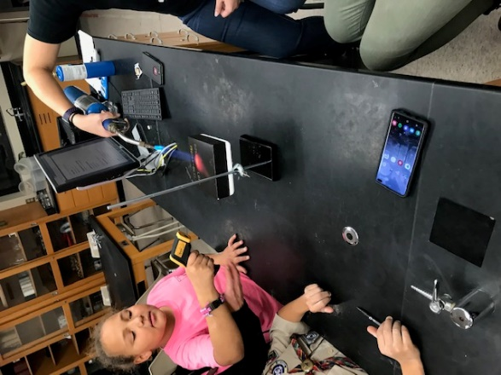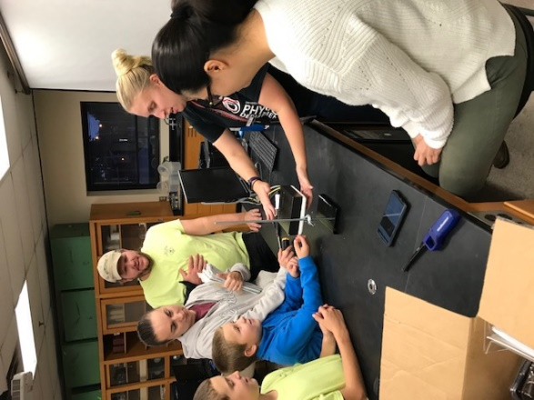
Photos 15 and 16: Heating the black Space Shuttle Tile Investigation!
Photo by: Doug Kaupa

What is housed in the dark Classroom 113? Is this a passageway into the twilight zone? No way! A lunar phase demo utilizing a 72 inch diameter beach ball representing the Earth and a 20 inch gray beach ball representing the Moon – all to scale. The lone bright light in the classroom is the Sun with students donning sunglasses and watching the Moon orbit the Earth counterclockwise, based on looking down on Earth’s North Pole. The students learn about a waxing and waning Moon and both sides of the Moon receive sunlight for nearly 14 days straight with 14 other days in the dark!

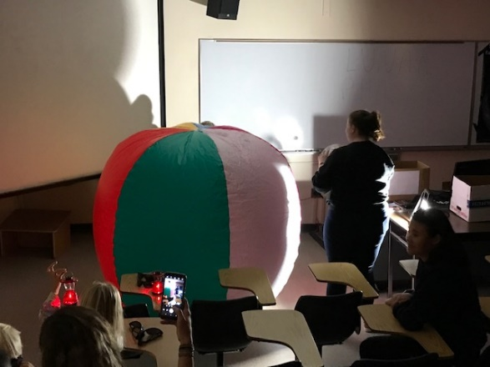
Photo 17: Lunar Phasing in the Twilight Classroom
Photo by: Doug Kaupa
Another fan favorite activity included experimenting on the angular momentum wheel as pictured in Figures 18 and 19. Children sit on platform, hold one bottle of water in each hand near their chest. The platform is then rotated and the children then extend their hands with bottles of water, slowing down. They experienced moving their mass moment of inertia outward from their center of rotation. Just like an ice skater, they now rotate slower. They speed up when they retracted their arms and similar to an ice skater, rotate more swiftly.

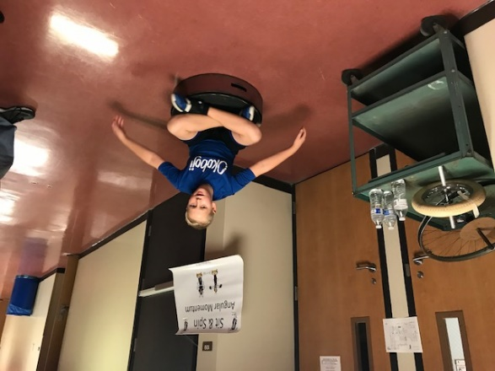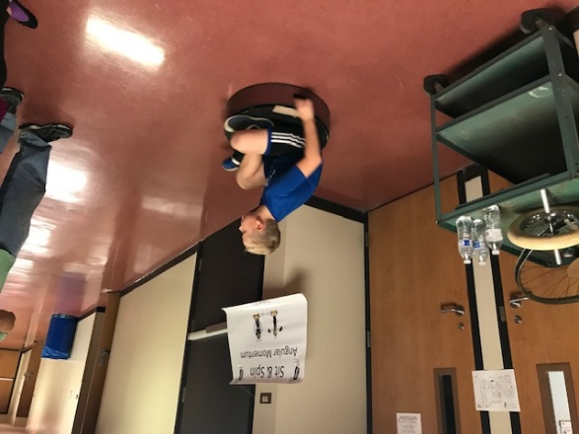
Photos 18 and 19: Rotating on Angular Momentum Theory
Photos by: Doug Kaupa

What is the fondest subject you enjoyed in high school? Gym class? Home Economics? How about Chemistry? That’s right, what class encouraged you to create stink grenades or permitted you to add flame to a reaction? In the Chemistry demo, children of all ages experimented with elephant toothpaste, explored ultraviolet light and dry ice! What is elephant toothpaste? It is a messy yet controllable experiment mixing hydrogen peroxide and dishwashing soap. Give the solution a few moments after mixing and watch the reaction! The toothpaste or foam will exceed the container volume swiftly!

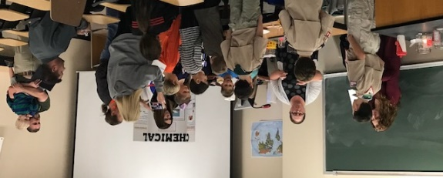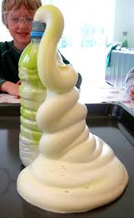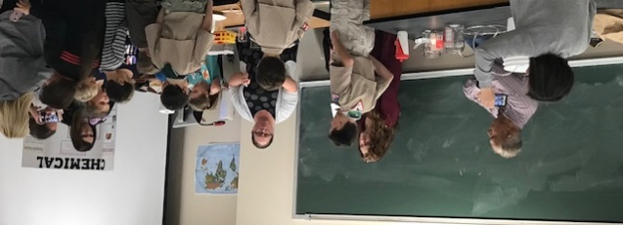
Photos 20, 21 and 22: Ode to Chemical Reactions!
Left and Right Photos (#20 and #22) by: Doug Kaupa
Middle Image (#21): fun-science.org.uk

Even wonder what a meteorite looks like? Or better yet, feels like? Have you ever been able to distinguish a meteorite from a meteor wrong? Using magnets and field magnified glasses, students of all ages can explore meteorites in their hands. The heavier meteorites usually are composed of iron and nickel mixtures. Magnets cling to them, which may indicate they came from a place far away. The stony meteorites look like every day rocks yet with the pocket magnified glasses, one can see a dark crust indicating one side of the rock has torch marks as it streamed through Earth’s atmosphere.
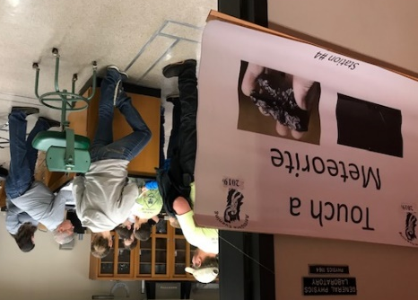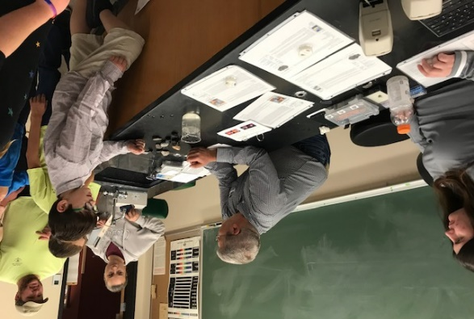
Photos 22 and 23: Meteorites in your Hands!
Photos by: Doug Kaupa

Just how big is Earth compared to the Gas or Icy Planets in our Solar System? In the photo below, Saturn without its rings is the large beach ball on the left. Earth is the tiny orange ball in the middle. Here at the Planetary Comparisons table, students grab the different balls and see just how much larger or smaller planets are compared to one another! Plus, slick planetary baseball cards with a planet picture on one side and awesome information on the other, is a great giveaway to the students!

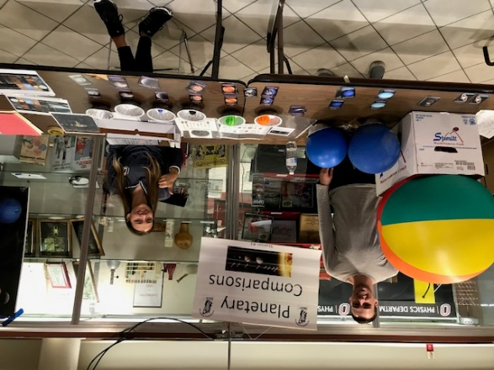
Photos 24: Earth is the tiny Orange Ball
Photo by: Doug Kaupa

In all, the evening lasted three hours, with over 250 children and adults in attendance. Thankfully the entire event sparkled due to an awesome team of volunteers, consisting of teachers, parents, donating organizations and local astronomy club helpers. Hearing the schoolchildren’s eureka moments encouraged the volunteers to host the event again in the coming school year, aiming to add robotics and other hands-on activities!

