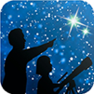
This article is distributed by NASA’s Night Sky Network (NSN).
The NSN program supports astronomy clubs across the USA dedicated to astronomy outreach. Visit nightsky.jpl.nasa.gov to find local clubs, events, and more!

August’s Night Sky Notes: The Great Rift
By Dave Prosper
Updated by Kat Troche
Summer skies bring glorious views of our own Milky Way galaxy to observers blessed with dark skies. For many city dwellers, their first sight of the Milky Way comes during trips to rural areas - so if you are traveling away from city lights, do yourself a favor and look up!
To observe the Milky Way, you need clear, dark skies and enough time to adapt your eyes to the dark. Photos of the Milky Way are breathtaking, but they usually show far more detail and color than the human eye can see – that’s the beauty and quietly deceptive nature of long exposure photography. For Northern Hemisphere observers, the most prominent portion of the Milky Way rises in the southeast as marked by the constellations Scorpius and Sagittarius. Take note that, even in dark skies, the Milky Way isn’t easily visible until it rises a bit above the horizon, and the thick, turbulent air obscures the view. The Milky Way is huge, but it is also rather faint, and our eyes need time to truly adjust to the dark and see it in any detail. Avoid bright lights as they will ruin your night vision. It’s best to attempt to view the Milky Way when the Moon is at a new or crescent phase; a full Moon will wash out any potential views.

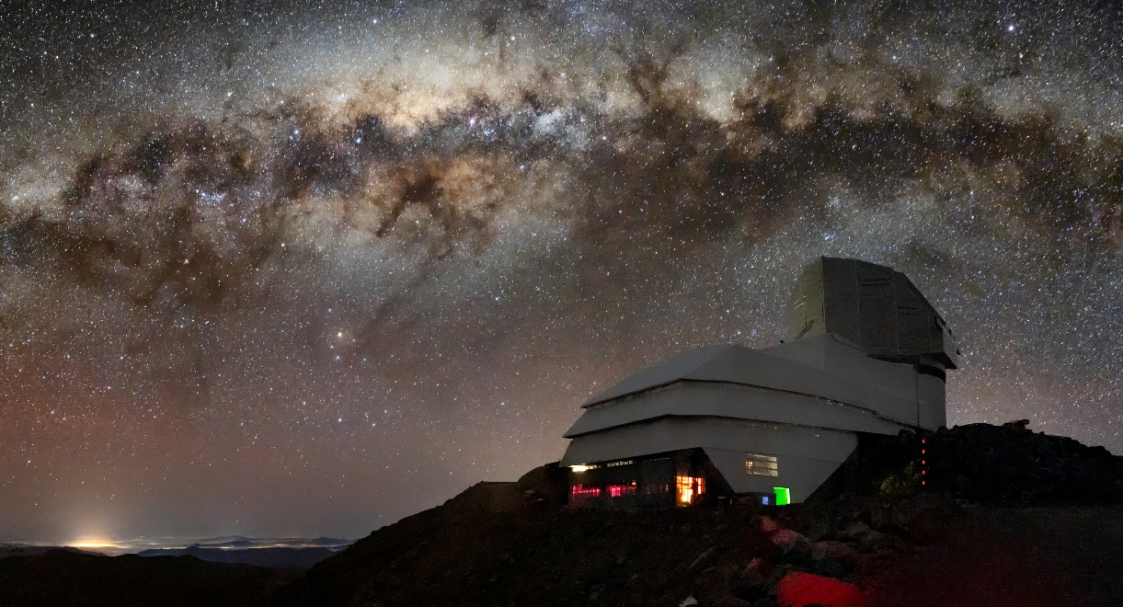
The Vera C. Rubin Observatory, located at Cerro Pachón, Chile, under the Milky Way. The bright halo of gas and stars on the left side of the image highlights the very center of the Milky Way galaxy. The dark path that cuts through this center is known as the Great Rift, because it gives the appearance that the Milky Way has been split in half. Image Credit: RubinObs/NOIRLab/SLAC/NSF/DOE/AURA/B. Quint

Keeping your eyes dark-adapted is especially important if you want to not only see the haze of the Milky Way, but also the dark lane cutting into that haze, stretching from the Summer Triangle to Sagittarius. This dark detail is known as the Great Rift, and is seen more readily in very dark skies, especially dark, dry skies found in high desert regions. What exactly is the Great Rift? You are looking at massive clouds of galactic dust lying between Earth and the interior of the Milky Way.

Other “dark nebulae” of cosmic clouds pepper the Milky Way, including the famed Coalsack, found in the Southern Hemisphere constellation of Crux. Many cultures celebrate these dark clouds in their traditional stories along with the constellations and the Milky Way. One such story tells of a Yacana the Llama, and her baby, wandering along a river that crossed the sky – the Milky Way. The bright stars Alpha and Beta Centauri serve as the llama's eyes, with the dark sections representing the bodies of mother and baby, with the baby below the mother, nursing.

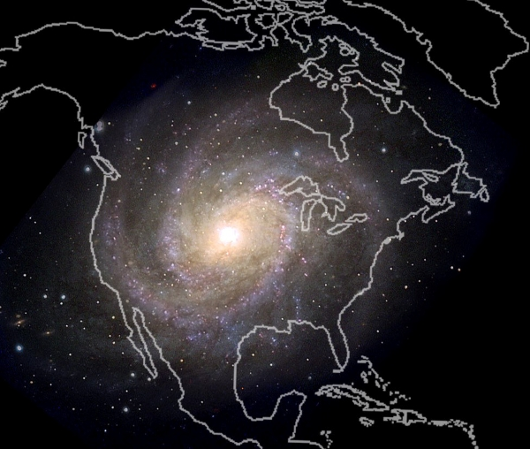
In the activity, "Our Place In Our Galaxy", if the Milky Way were shrunk down to the size of North America, our solar system would be about the size of a quarter. At that scale, Polaris - which is about 433 light years distant from us - would be 11 miles away. Image Credit: Astronomical Society of the Pacific

Where exactly is our solar system within the Milky Way? Is there a way to get a sense of scale? The “Our Place in Our Galaxy” activity can help you do just that, with only birdseed, a coin, and your imagination. You can also discover the amazing science NASA is doing to understand our galaxy – and our place in it - in the Galaxies section of NASA's Universe page.

Originally posted by Dave Prosper: June 2021
Last Updated by Kat Troche: July 2025

