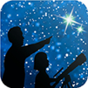
This article is distributed by NASA’s Night Sky Network (NSN).
The NSN program supports astronomy clubs across the USA dedicated to astronomy outreach. Visit nightsky.jpl.nasa.gov to find local clubs, events, and more!

October’s Night Sky Notes: Let’s Go, LIGO!
By Kat Troche

September 2025 marks ten years since the first direct detection of gravitational waves as predicted by Albert Einstein’s 1916 theory of General Relativity. These invisible ripples in space were first directly detected by the Laser Interferometer Gravitational-Wave Observatory (LIGO). Traveling at the speed of light (~186,000 miles per second), these waves stretch and squeeze the fabric of space itself, changing the distance between objects as they pass.

Waves In Space

Gravitational waves are created when massive objects accelerate in space, especially in violent events. LIGO detected the first gravitational waves when two black holes, orbiting one another, finally merged, creating ripples in space-time. But these waves are not exclusive to black holes. If a star were to go supernova, it could produce the same effect. Neutron stars can also create these waves for various reasons. While these waves are invisible to the human eye, this animation from NASA’s Science Visualization Studio shows the merger of two black holes and the waves they create in the process.

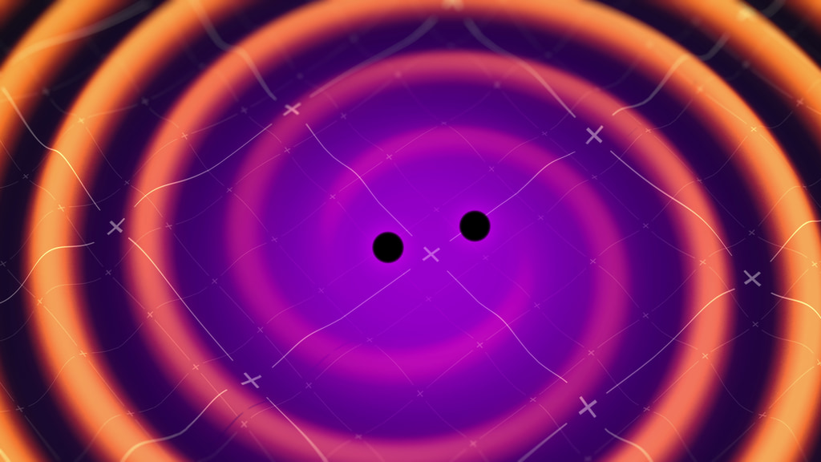
Two black holes orbit around each other and generate space-time ripples called gravitational waves in this image. Credit: NASA's Goddard Space Flight Center Conceptual Image Lab

How It Works
A gravitational wave observatory, like LIGO, is built with two tunnels, each approximately 2.5 miles long, arranged in an "L" shape. At the end of each tunnel, a highly polished 40 kg mirror (about 16 inches across) is mounted; this will reflect the laser beam that is sent from the observatory. A laser beam is sent from the observatory room and split into two, with equal parts traveling down each tunnel, bouncing off the mirrors at the end. When the beams return, they are recombined. If the arm lengths are perfectly equal, the light waves cancel out in just the right way, producing darkness at the detector. But if a gravitational wave passes, it slightly stretches one arm while squeezing the other, so the returning beams no longer cancel perfectly, creating a flicker of light that reveals the wave’s presence.

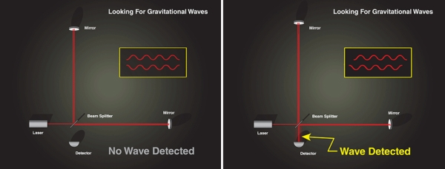

Still images of how LIGO (Laser Interferometer Gravitational-Wave Observatory) detects gravitational waves using a laser, mirrors, and a detector. You can find the animated version here. Image Credit: NASA

The actual detection happens at the point of recombination, when even a minuscule stretching of one arm and squeezing of the other changes how long it takes the laser beams to return. This difference produces a measurable shift in the interference pattern. To be certain that the signal is real and not local noise, both LIGO observatories — one in Washington State (LIGO Hanford) and the other in Louisiana (LIGO Livingston) — must record the same pattern within milliseconds. When they do, it’s confirmation of a gravitational wave rippling through Earth. We don’t feel these waves as they pass through our planet, but we now have a method of detecting them!

Get Involved
With the help of two additional gravitational-wave observatories, VIRGO and KAGRA, there have been 300 black hole mergers detected in the past decade; some of which are confirmed, while others await further study.
While the average person may not have a laser interferometer lying around in the backyard, you can help with two projects geared toward detecting gravitational waves and the black holes that contribute to them:
- Black Hole Hunters: Using data from the TESS satellite, you would study graphs of how the brightness of stars changes over time, looking for an effect called gravitational microlensing. This lensing effect can indicate that a massive object has passed in front of a star, such as a black hole.
- Gravity Spy: You can help LIGO scientists with their gravitational wave research by looking for glitches that may mimic gravitational waves. By sorting out the mimics, we can train algorithms on how to detect the real thing.
You can also use gelatin, magnetic marbles, and a small mirror for a more hands-on demonstration on how gravitational waves move through space-time with JPL’s Dropping In With Gravitational Waves activity!

