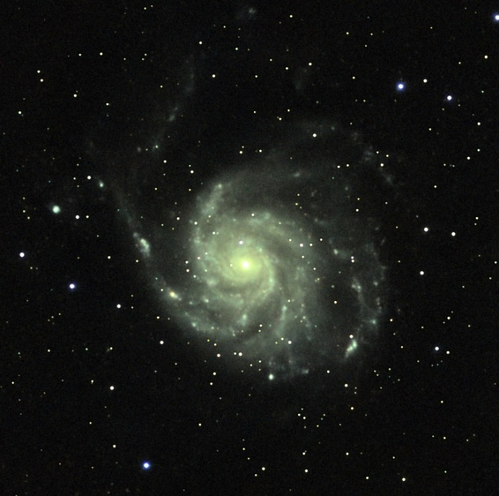
M101 Pinwheel Galaxy

Proposed 2026 Dates&Start Time
6/19 9:00PM
7/17 9:00PM
8/21 8:30PM
9/18 8:00PM
10/16 7:00PM
11/20 5:30PM
This is Normally Scheduled for the 3rd Friday of the Month.
FREE STAR PARTY
Date: Friday June 19th
Time: 9:00PM till 12:00AM
Where: Fort Monroe, VA

Fort Monroe and NASA Skywatchers are sponsoring a FREE Star Party, at the North end of the air strip across from the Paradise Club and near the Colonies RV & Travel Park. Local amateur Astronomers will be on site with their equipment to provide amazing sky views and sky tours. This event is of course weather dependent. Check NASA Skywatchers Facebook page for information on event weather cancellations by 3 PM on Friday before event.

Apr
spr”
For Directions and Parking Instructions Flip Page Over.

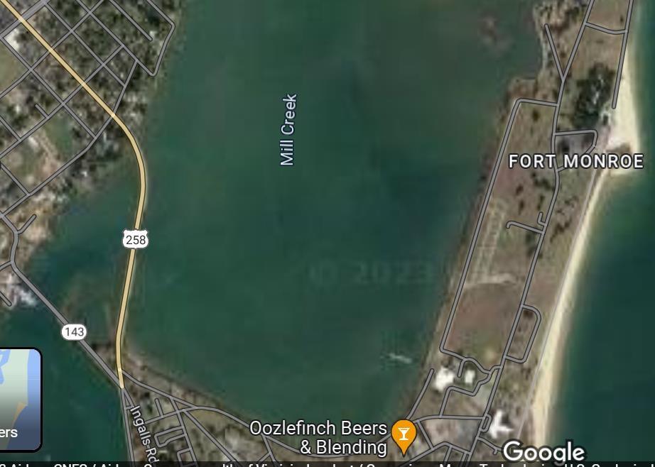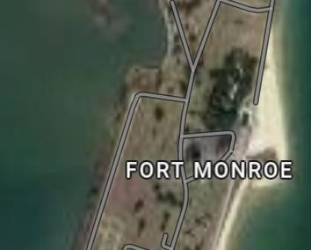
Parking Rules to Preserve Night Vision of Star Party:
People/members with Telescopes who will stay for the duration of the Star Party can park next to their Telescopes in “Telescope Parking”. People/members with telescopes “NOT” planning on staying for the duration of the Star Party, can drive to “Telescope Parking”, but leave vehicle facing the main road so headlights do not shine on main telescope setups when you leave. Visitors, please park at the tennis court/event parking area. Handicap Visitors with valid plates can park in Telescope Parking area following rules for members not staying for the duration of the Star Party. Note: Paradise Club parking lot is now restricted to the Paradise Club only.

Parking:

Colonies RV
& Travel
Park

Star Party

Location

Paradise
Club

Telescope Parking
End of Runway

Visitor Parking

