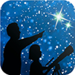
NASA’s Night Sky Network (NSN) distributes this article.
The NSN program supports astronomy clubs across the USA dedicated to astronomy outreach. Visit nightsky.jpl.nasa.gov to find local clubs, events, and more!

November’s Night Sky Notes: Light-Day Away
By Kat Troche

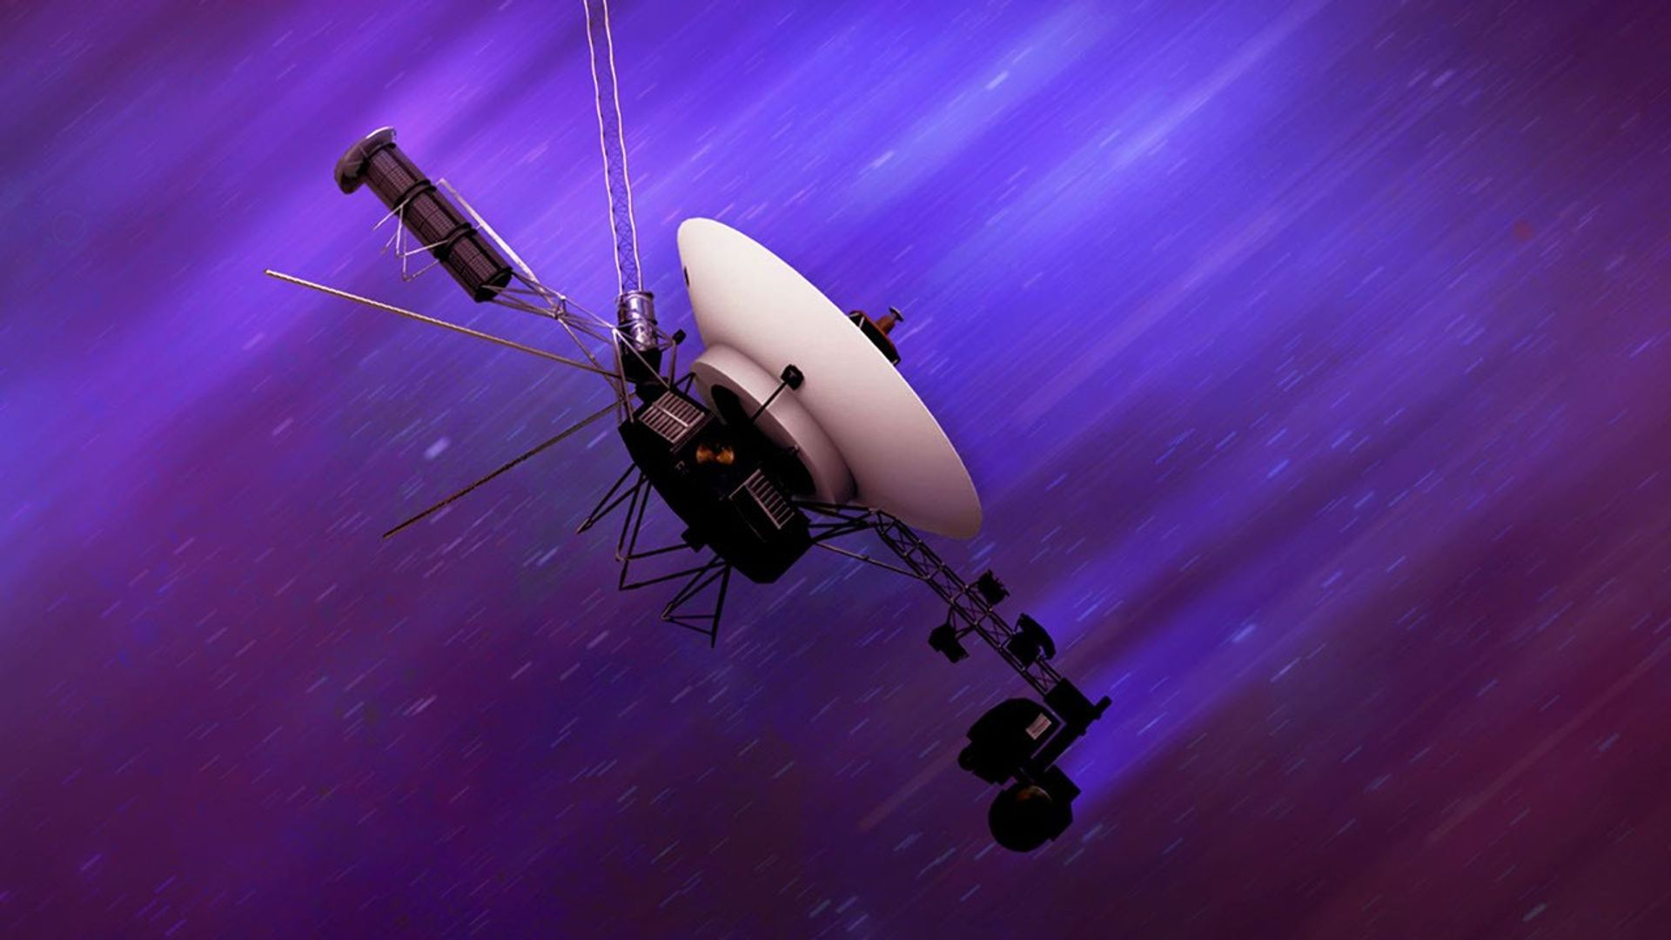
A travel poster of The Grand Tour. Credit: NASA/JPL

Twin Travelers
In 1977, NASA launched twin spacecraft Voyager 1 and 2, taking advantage of a once-every-175-year planetary alignment of the four largest planets in our solar system: Jupiter, Saturn, Uranus, and Neptune. Using six gravity assists between them, this Grand Tour gave us up-close views of the gas and ice giants, including several moons. By the 1980s, the two probes went their separate ways at Saturn. As Voyager 2 continued toward Uranus and Neptune, Voyager 1 grabbed one more portrait of the solar system (excluding Mercury and Mars), including a final image of the pale blue dot we call home.

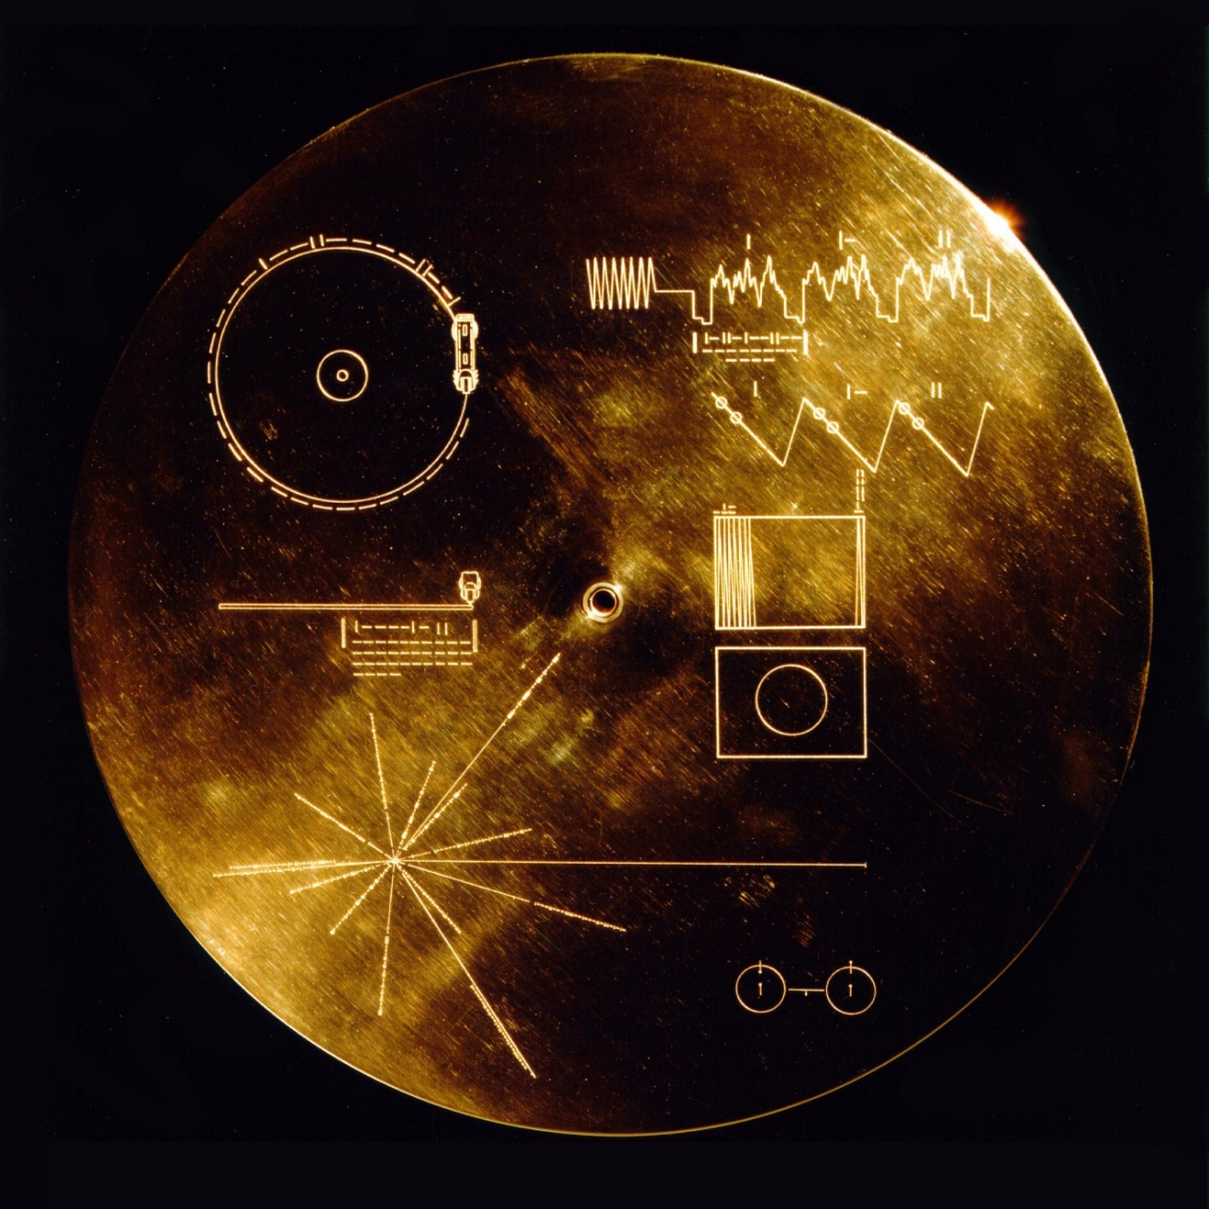
The Golden Record cover shown with its extraterrestrial instructions. Credit: NASA/JPL-Caltech

Playlist
“Hello from the children of planet Earth.”

Every good road trip needs some music to match. In this case, each craft carries the Golden Record, a 12-inch phonograph record with spoken greetings in 55 languages, 27 musical tracks, 116 images, and other sounds from Earth. Each record is protected by an outer cover featuring etchings showing our Sun's location relative to 14 pulsars, along with instructions on how to play it. The design used various metals to protect the information encoded from space radiation: the record used copper and gold plating, and the cover used aluminum. The cover was electroplated with an ultra-pure sample of the isotope uranium-238. Uranium-238 has a half-life of 4.468 billion years.

Are We There Yet?
Did you know that a light-minute is a measure of distance, not time? In August 2012 and November 2018, Voyager 1 and 2 crossed the heliopause, the boundary where the Sun’s solar wind meets the interstellar medium. Using NASA’s Deep Space Network, Earth communicates with both spacecraft and tracks each on its journey. At the time of this article, the Canberra antenna tracked Voyager 1 at 25.80 billion km, or just over 16 billion miles.

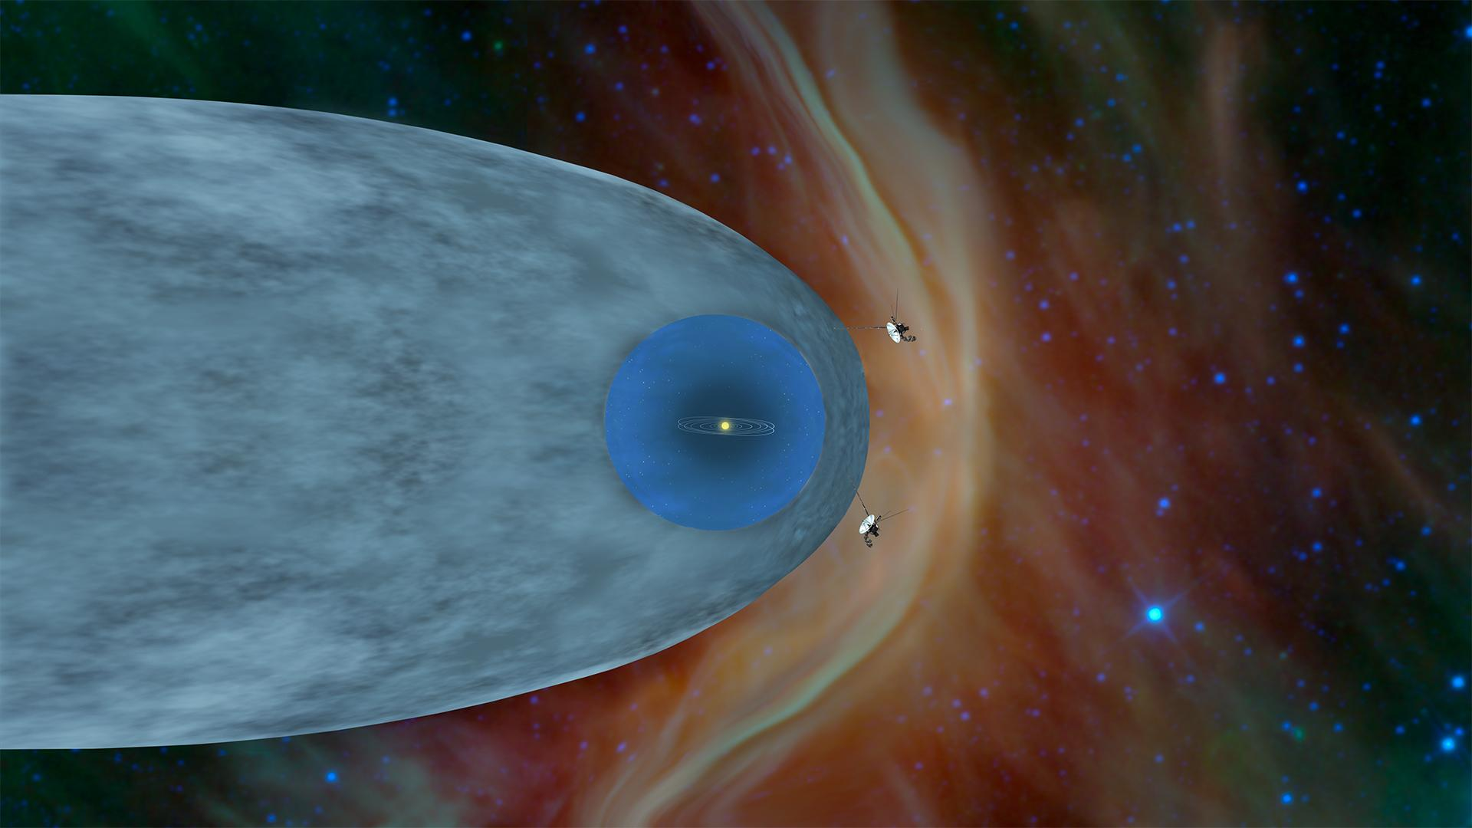
This illustration shows the positions of NASA's Voyager 1 and Voyager 2 probes outside the heliosphere, a protective bubble created by the Sun that extends well past Pluto's orbit. The red wave in front of the light blue heliopause is the bow shock. Credit: NASA/JPL-Caltech.

On November 18, 2026, 49 years after its launch, Voyager 1 will cross the one-light-day mark, 16.1 billion miles from the Sun. You may have heard the term light-year in your favorite sci-fi movie or show, or when stargazing and referring to an object outside of our solar system. This video best demonstrates the different distances between the inner solar system, outer solar system, and beyond, using light measurements. Additionally, track each Voyager spacecraft here.

You can get a real understanding of what a gravity assist might be like with our Gravity Assist activity and learn what it’s like to measure a “light minute” with our Measuring a Kid Minute activity guide!

